
THE CHINESE UNIVERSITY

OF HONG KONG (SHENZHEN)

School of Science and Engineering

Tutorial - 2

Fundamental of Artificial Intelligence CSC3180

- Answer the following questions:

- A goal-based agent is often used other than a reflex agent. Could you answer why? (L3: P9)
- As a problem-solving agent, please understand its two formulations: Goal and Problem Formulation. (L3: P11-17)
- A problem can be defined by five components, what are they? (L3: P18-19)

- What are the variants of breadth-first search and depth-first search? (L3: P47)

- How to understand the five components for a given node? (L3: P41)

- What are the three types of queue? What difference between FIFO quere and LIFO queue, and how to implement each? (L3: P43)

- Using expanding from initial state to goal in a search tree, some problems could be solved in final. How to avoid the repeated states during searching? (L3: P32-37)

- Please explain four kind of measuring performance to evaluate a search strategy. (L3: P44)

- Two type of search strategies, uninformed search and informed search, are defined in P46, L3. Could you compare their difference?

- A problem can be formulated in different ways. Please formulate the 8 queens problem using incremental formulation and complete-state formulation. (L3: P26-29)

- What data structure should be used to store the frontier in breadth-first search, uniform-cost search and depth-first search, respectively? (L3: P48-54)

- In Lecture 3, the solution of a problem is define as a path from the initial state to a state satisfying the goal test. As two examples in the following, please find out the optimal solution with lowest path cost among the given solutions.
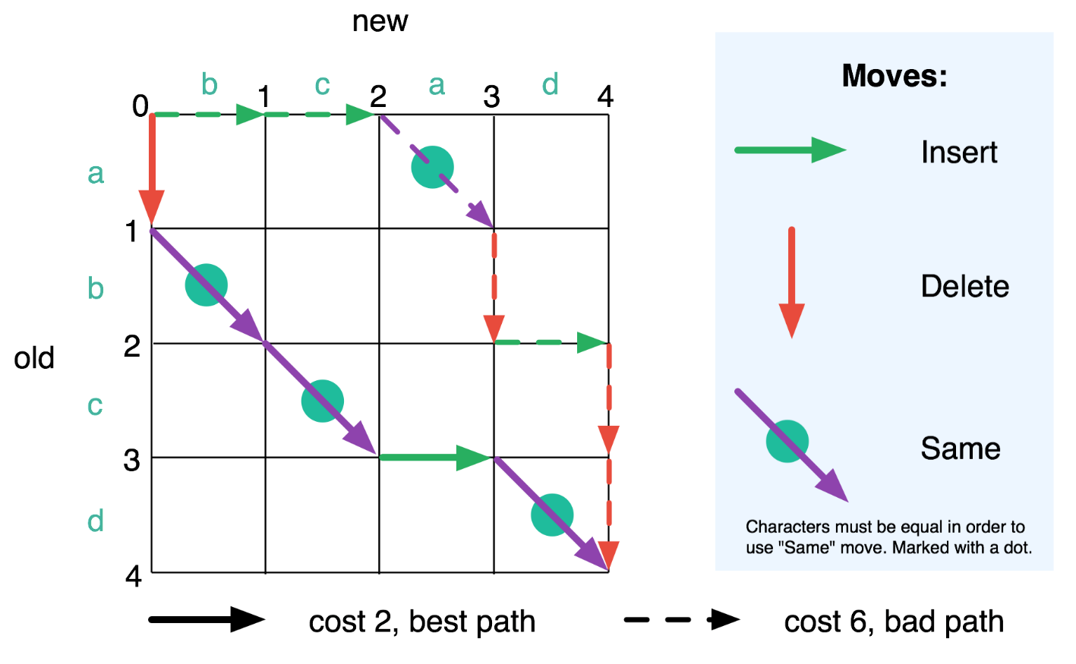 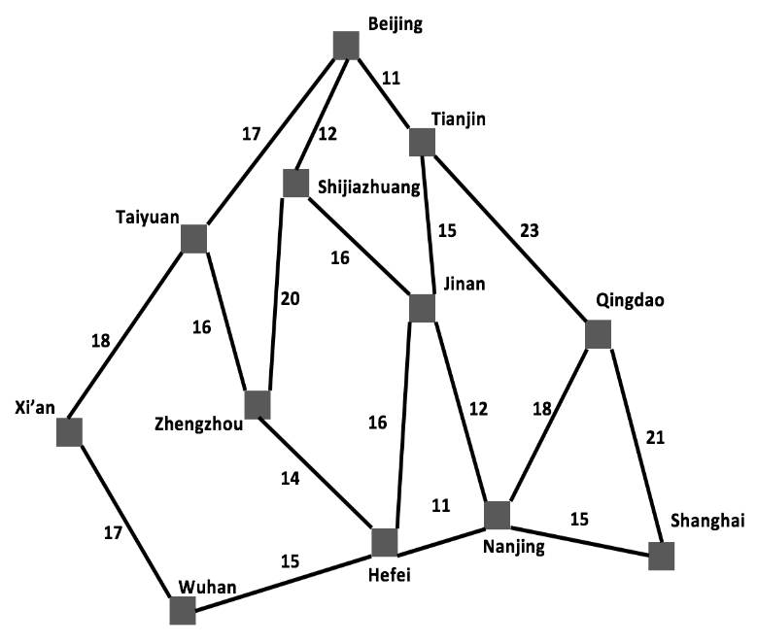 Beijing→Shanghai

- An example of Vacuum World is shown in P22, Lecture 2. There are the total 8 states. Could you use a truth table to represent each state?

- Search the following tree using breadth-first search (L3: 48-50) and depth-first search (L3: 53-55) respectively (starting with node 1). What is the order of the expanded nodes?
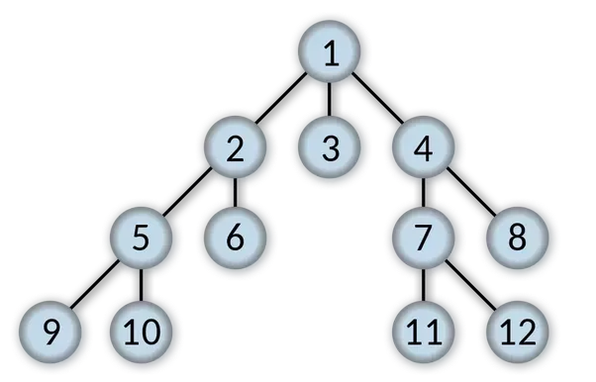

- Search the following graph with breadth-first search and uniform-cost search respectively (S: starting state, G: goal state). What is the order of the expanded nodes? (L3: P51)
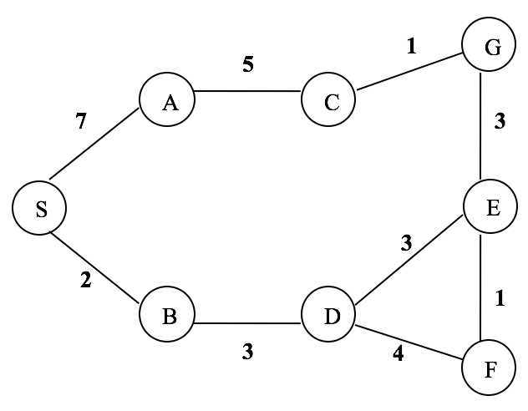

- Given a binary tree as follows, we should like to search it using Breadth-First Search and Depth-First Search, respectively. Please list each number of nodes generated, time and space complexity.
